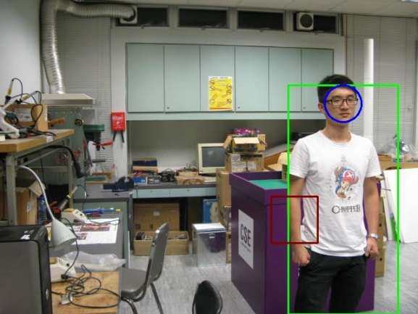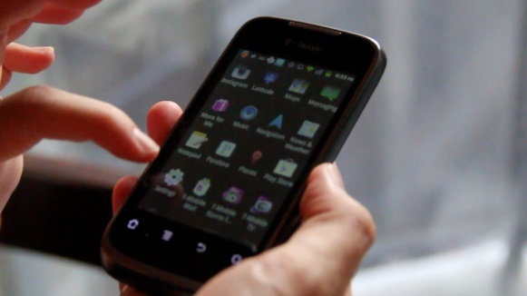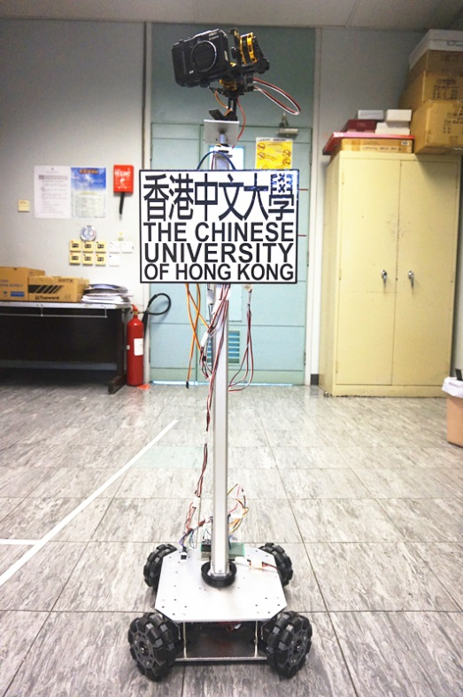

***Figure 3 Using face detection and pedestrian detection and skin color filtering to locate the targets***

*The robot uses OpenCV as the core module, together with some methods to estimate the position of the targets. After the estimation, the robot will figure out a strategy to move the target into the expected region, so that the target will appear in the final picture as the user has expected it to be.*

***Figure 2. Android phone as the User Interface***

*The APP on android phone let you send necessary configurations to the robot, and receive the final photo from the robot.*

**Settings**

**Photos**

The HIGHLY AUTOMATIC PHOTOGRAPHER ROBOTS (HAPR) is based on the Intel Bay Trail platform, and uses Omini Robot as the motion system, with self-built camera platform to have better orientation control. An mbed is deployed as the translator between the Intel development board and the Omini Robit, so it is possible for the development board to control multiple devices using single USB port.

***Figure 1. THE HIGHLY AUTOMATIC PHOTOGRAPHER ROBOT***

|  |
| --- |
| **Project Title:**  **HIGHLY AUTOMATIC PHOTOGRAPHER ROBOT** |
| Team Members: Lai Jing Tao, Yi Wei Ying, Huang Zi Long |
| **Highly Automatic Photographer Robot is a robot that can provide great helps when you cannot find a photographer to record the very moment in your life.(what problem we solved)** |

